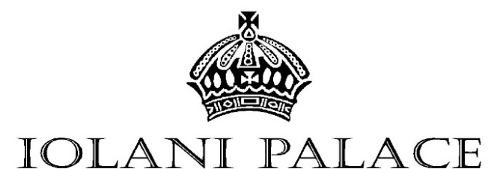
Basic Benefits of Membership
- Free admission to Iolani Palace & Palace Galleries
- 10% discount on most items at The Palace Shops
- Subscription to The Friends of Iolani Palace newsletter
- Invitations and reserved seating for special events
- Invitation to the Annual Meeting and reception

The Friends of ‘Iolani Palace Membership Application

MEMBERSHIP LEVELS

O Na Kupuna (Seniors*) | $40
O Na Kakoo (Individuals) | $50
O Na Ohana (Family) | $100
O Na Kahu (Attendants) | $500
O Chamberlain’s Circle | $1,000
O Kalakaua Circle | $5,000
O Liliuokalani Society | $10,000
*Seniors = 65+ years
YES, I'd like to be a Friend of ‘Iolani Palace!
Name Mr. / Ms. / Mrs.
Street Address
City | State | Zip
Phone# ( )
E-maiL

METHOD OF PAYMENT
O Cash | O Check
O Amex | O Discover | O Mastercard | O Visa

Card number
Expiration date | CVV
Signature of cardholder
I wish to make an additional donation of ___________
Total enclosed or amount to be charged ___________

Please make checks payable to:

The Friends of ‘Iolani Palace
Your gift is tax deductible as provided by law.

The following categories receive
all the basic benefits:

Na Kupuna (Seniors 65+ years of age) $40
Na Kakoo (Supporting Individuals) $50
Memberships at the Na Ohana level and above receive all of the basic benefits (with free admission to include two adults and any minor children living at the same address), plus the following additional privileges:

Nā ‘Ohana (Family) $100
Two Guided Tour passes*

Nā Kahu (Attendants) $500
Two Guided Tour passes, two gallery passes, and an ‘Iolani Palace bookmark

Chamberlain’s Circle $1,000
Four Guided Tour passes, four gallery passes, and a $25 gift certificate redeemable at The Palace Shop or the Gallery Shop

Kalakaua Circle $5,000
Four Guided Tour passes, four gallery passes, the most current Iolani Palace ornament available, and a $50 gift certificate redeemable at The Palace Shop or the Gallery Shop

Liliuokalani Society $10,000
Four Guided Tour passes, four gallery passes, the most current Iolani Palace ornament available, and a $100 gift certificate redeemable at
The Palace Shop or the Gallery Shop

*Guided Tour passes and Gallery passes are good for one-time only admission

Mail to:
Iolani Palace, P.O. Box 2259
Honolulu, HI 96804

Phone: (808) 522-0827
www.iolanipalace.org
members@iolanipalace.org

